# Press Release #29

# “Expanding the Supply Chain Financing Market” Seminar

# The Mongolian National Chamber of Commerce and Industry (MNCCI), in collaboration with the Financial Regulatory Commission, the Mongolian Bankers Association, and the International Finance Corporation, will organize a one-day seminar on “Expanding the Supply Chain Financing Market.”

# This seminar will provide participants with insights into:

# What supply chain financing is

# Opportunities for supply chain financing in the Mongolian market

# The seminar will take place on July 4, 2025, at the Grand Hall of the MNCCI.

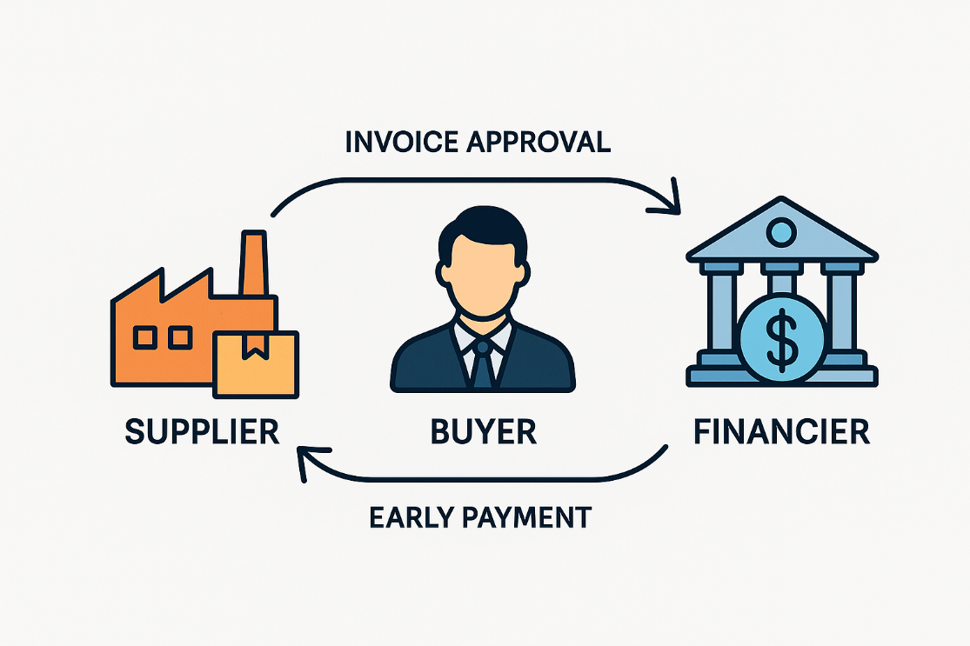

An invitation to participate in the seminar is attached.

For further information, please contact Project Manager Ms. Enerel.A.

Email: enerel@mongolchamber.mn, Phone: +976-88108745

*The "Capacity building to the Mongolian vegetable tanned yak leather on bio-leather and bio-leather products" project* ***- Sustainable Yak Leather (SYL) project -*** *is funded by the EU, within the framework of the SWITCH-Asia Grants Programme. For further information about SWITCH-Asia Grants Programme, please visit* [*www.switch-asia.eu*](http://www.switch-asia.eu/)